PHP/Apache/MySQL   
Web Application Development

## **e-commerce / Online Shop**

Timos Mukoko K00203438 SD – Group B

# EER Model

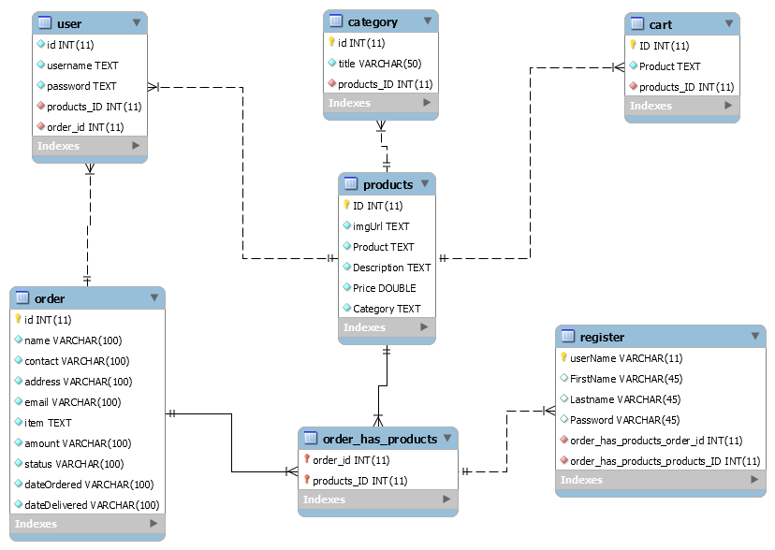

# Normalization

PK

category_id

2NF? Y

title

PK

cart_id

2NF? Y

Product

PK

products_ID

2NF? N

imgUrl

Category

Price

Description

Product

PK

user_id

2NF? N

2NF? N

2NF? N

PK

order_id

2NF? N

2NF? Y

username

password

2NF? Y

2NF? N

dateDeliverd

dateOrdered

status

amount

item

email

address

contact

name

2NF? N

2NF? N

2NF? N

2NF? N

2NF? N

2NF? N

2NF? N

2NF? N

1. USER TABLE

PK

3NF? Y

3NF? Y

PK

user_id

products_ID

user_id

username

password

PK

3NF? Y

User_id

Order_id

3NF? Y

User={user_id, products_ID, order_id, username, password}

1. PRODUCTS TABLE

3NF? Y

products_ID

imgUrl

Product

Description

Price

Category

3NF? Y

3NF? Y

3NF? Y

3NF? Y

PK

Products={products_ID, imgUrl, Product, Description, Price, Category}

1. ORDER TABLE

3NF? Y

dateDeliverd

dateOrdered

status

amount

item

email

address

contact

name

3NF? Y

3NF? Y

3NF? Y

3NF? Y

3NF? Y

3NF? Y

3NF? Y

3NF? Y

PK

order_id

Order={order_id, name, contact, address, email, amount, status, dateOrdered, dateDelivered}

1. CATEGORY TABLE

PK

3NF? Y

category_id

title

3NF? Y

PK

products_ID

category_id

Category={category_id, products_ID, title}

1. CART TABLE

PK

3NF? Y

cart_id

Product

PK

3NF? Y

products_ID

cart_id

Card={card_id, products_ID, Product}

ORDER_AS_PRODUCTS & REGISTER TABLE -> NF2

2NF? Y

PK

FirstName

order_id

products_ID

PK

Lastname

2NF? Y

username_id

2NF? Y

2NF? Y

Password

3NF? N

PK

FirstName

order_id

products_ID

PK

Lastname

3NF? N

username_id

3NF? Y

3NF? N

Password

1. ORDER_AS_PRODUCTS

PK

Username_id

order_id

products_ID

3NF? Y

Oreder_as_products={order_id, products_id, username_id}

1. REGISTER TABLE

Lastname

3NF? Y

FirstName

username_id

PK

3NF? Y

3NF? Y

Password

Register={username_id, FirstName, Lastname, Password}